**From Roots to Roads: Tata Motors’ Evolution in the Global Automotive Industry**



**ACKNOWLEDGEMENT**

I am highly grateful to the **MISS DIKSHA MA’AM**, IBM FACULTY **SHRI RAMSWAROOP MEMORIAL UNIVERSITY LUCKNOW** for providing this opportunity to carry out the major project work at. The constant guidance and encouragement received from MISS DIKSHA MA’AM H.O.D IBM DEPARTMENT has been of great help in carrying out the project work and is acknowledged with reverential thanks. I would like to express a deep sense of gratitude and thanks profusely to Project Guide Name, without his/her wise counsel and able guidance, it would have been impossible to complete the project in this manner. I express gratitude to other faculty members of Analytics and department of SRMU for their intellectual support throughout the course of this work.

Finally, I am indebted to all whosoever have contributed in this report work.

**MISS DIKSHA PANDIT**

**PANKHURI NIGAM**

**TABLE OF CONTENT**

**CONTENTS**

**ABSTRACT**

**ACKNOWLEDGEMENT**

**CHAPTER 1** - Introduction

**CHAPTER 2** - Problem definition

**CHAPTER 3** - Empathy map

**CHAPTER 4** - Persona Perspective

**CHAPTER 5** - Video scenario

**CHAPTER 6** - Storyline

**CHAPTER 7** - Storyboard

**CHAPTER 8** - Priority grid

**CHAPTER 9** - Crafting Hills

**ABSTRACT**

Tata Motors is a big company that makes cars and trucks. This abstract talks about how Tata Motors has changed and grown over time.

First, we look at where Tata Motors started and how it became a top carmaker. We then see the problems Tata Motors faced, like new technology and what people want in cars.

The abstract shows how Tata Motors tackled these challenges. They focused on making new and eco-friendly cars, like electric and hybrid ones. Tata Motors also put a lot of effort into making cars that can drive by themselves, called autonomous cars. This shows they're keeping up with the latest trends.

The abstract also talks about how Tata Motors is not just in one place but sells cars all over the world. They are working hard to be a strong player in new and growing markets.

Tata Motors didn't do this alone. They teamed up with other companies and schools to bring in new ideas and make better cars. This abstract looks at these partnerships and how they help Tata Motors stay ahead.

In the end, the abstract looks to the future. Tata Motors will keep changing and growing. It will be important for them to keep up with what people want and to keep trying new things. This abstract gives a simple view of how Tata Motors is driving change in the auto world.

Tata Motors is a big company that makes cars and trucks, and its story is like an exciting journey. Imagine a company that started small and grew into a top carmaker known all around the world – that's Tata Motors!

**INTRODUCTION**

In the beginning, Tata Motors was like a tiny seed planted by the Tata Group, and over time, it grew into a giant tree in the automotive world. This company didn't just stick to one place; it spread its branches globally, making and selling cars everywhere.

But, like every journey, there were challenges along the way. Tata Motors faced things like new technologies and figuring out what people really wanted in their cars. However, instead of backing down, Tata Motors decided to tackle these challenges head-on.

One cool thing about Tata Motors is its commitment to making cars that are good for the planet. They didn't just stop at regular cars – they also jumped into making electric and hybrid cars, which are like superheroes for the environment.

And that's not all! Tata Motors is even working on cars that can drive themselves. Yes, you heard it right – cars that can go on their own! This shows how Tata Motors is always looking ahead, trying to bring the future into today's world.

But Tata Motors didn't do all of this alone. They teamed up with other companies and schools to get new ideas and make even better cars. It's like having a bunch of friends to help you on your journey.

As we look ahead, Tata Motors continues to grow and change. The future is like an open road for them, and they are ready to steer into new opportunities, always keeping in mind what people need and want. Tata Motors is not just a car company; it's a driving force in the world of cars and trucks, making its mark on the road to the future.

**PROBLEM DEFINATION**

**HOW MIGHT WE STATEMENT?**

1.How might we design vehicles at Tata Motors that seamlessly integrate cutting-edge technology, ensuring a user-friendly and enjoyable driving experience for our customers?

2. How might we incorporate sustainable and eco-friendly materials in the manufacturing process, reducing the environmental impact of our vehicles while maintaining high safety and quality standards?

3. How might we empathize with diverse customer needs and preferences to create a range of customizable features and options, providing personalized solutions that cater to a wide range of tastes and requirements?

4. How might we streamline the maintenance and service processes for Tata Motors vehicles, ensuring convenience and efficiency for customers while minimizing downtime and enhancing overall ownership experience?

5. How might we foster collaborative partnerships with other industries, technology experts, and creative minds to explore new ideas and bring fresh perspectives into the design and development of Tata Motors' next-generation vehicles?

**EMPATHY MAP**

An empathy map serves as a valuable tool within design thinking and user experience (UX) design, aiding teams in gaining deeper insights into their users or customers. It offers a straightforward framework segmented into various aspects of the user's experience, including their **thoughts, emotions, observations, and actions.**

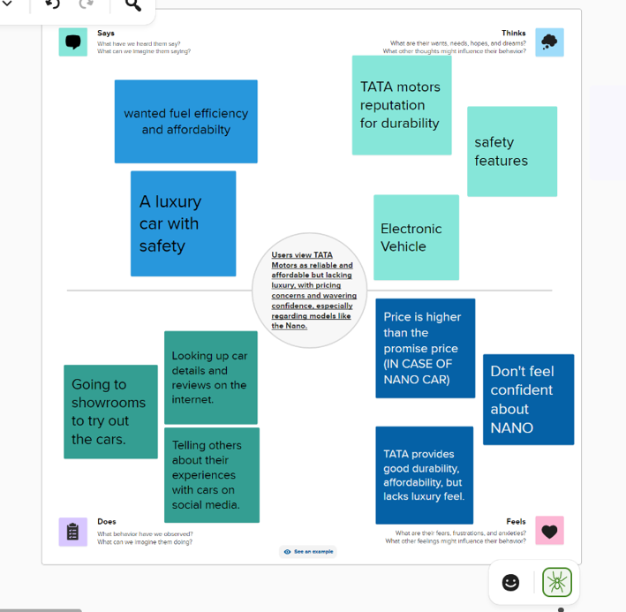

**PERSONA PERSPECTIVE**

Personas are like made-up people who stand for the different kinds of users that could use a product, service, or system. They're created using information from real users and **help design teams imagine and get what their target audience wants**, aims for, and does.

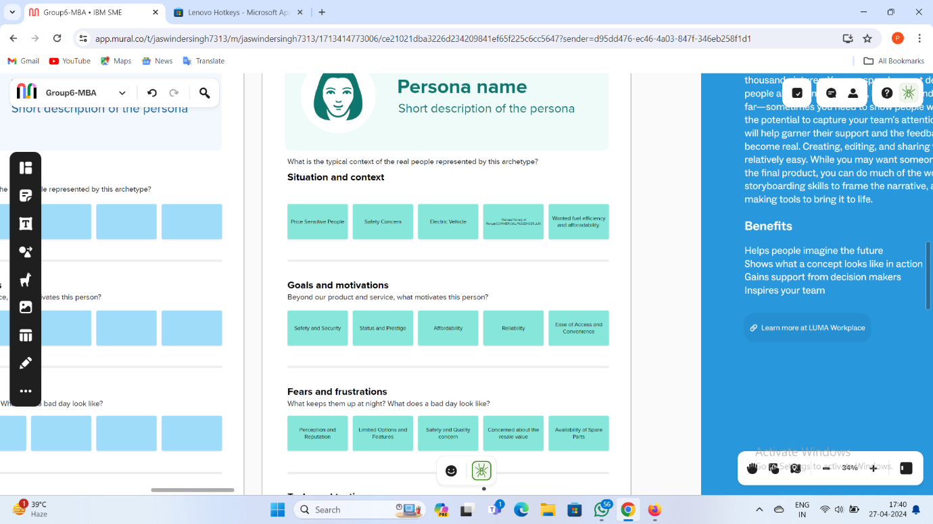

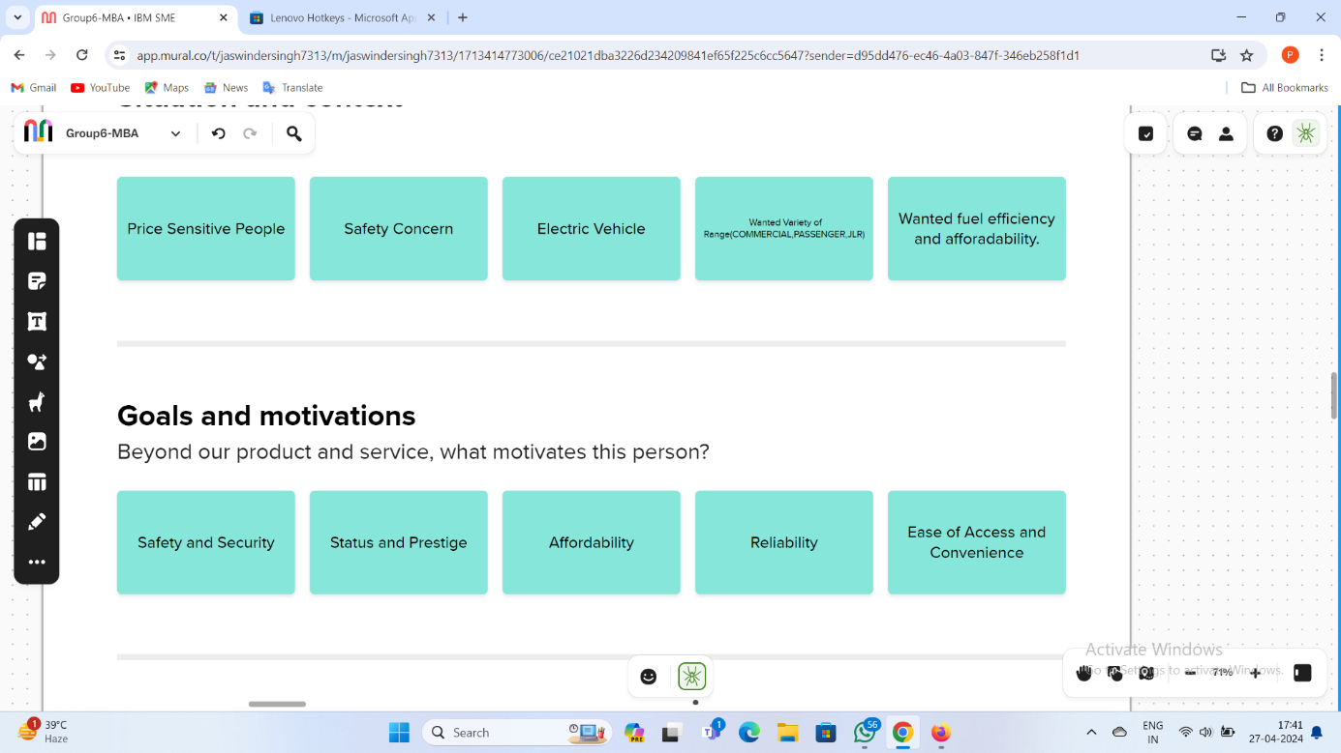

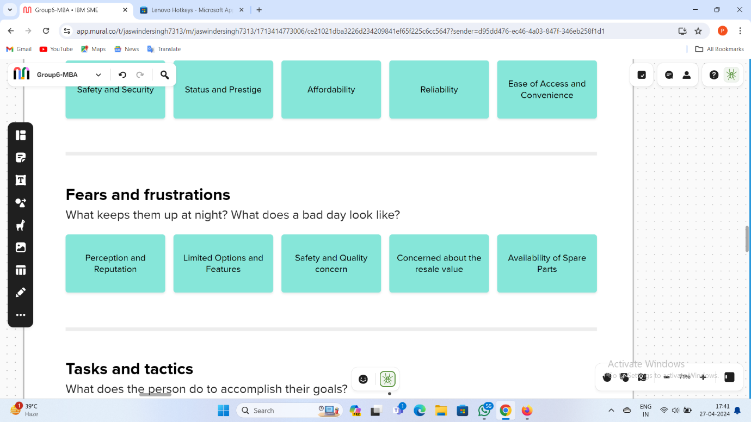

**VIDEO SCENARIO**

Teams can utilize MURAL's digital canvas **to craft storyboards** outlining a video's events. Each frame depicts crucial moments or scenes. MURAL enables the incorporation of visuals like pictures, icons, and shapes, aiding in illustrating actions and interactions. Additionally, teams can include text notes for context or more details.

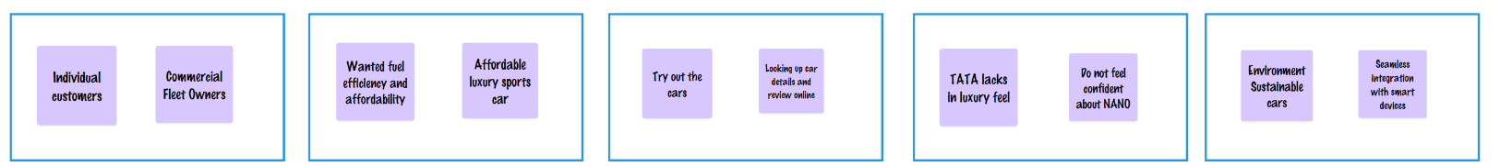

**STORYLINE**

**Employing MURAL's digital canvas to visually plot the storyline** of a tale, including crafting a timeline, pinpointing major plot moments, and arranging scenes or chapters. Experimenting with interactive storytelling methods in MURAL, like branching narratives or choose-your-own-adventure plots, by developing interactive prototype to assess various story paths and results.

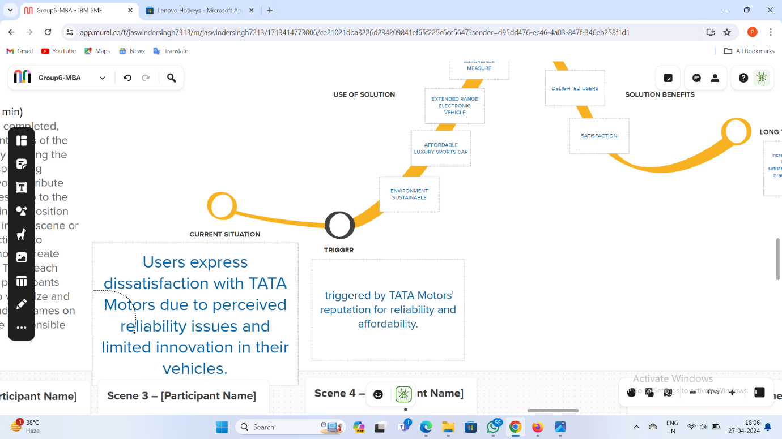

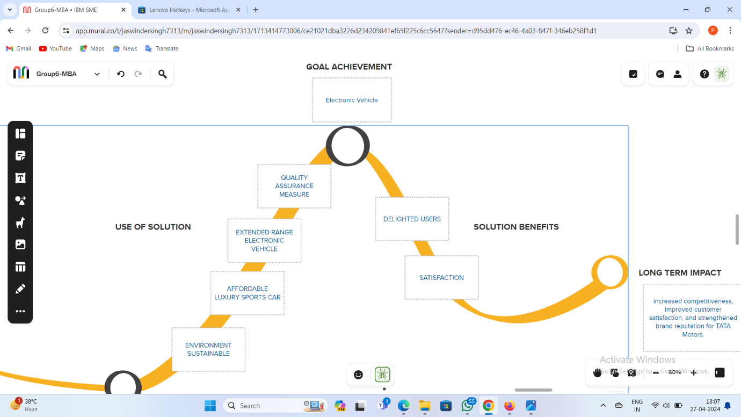

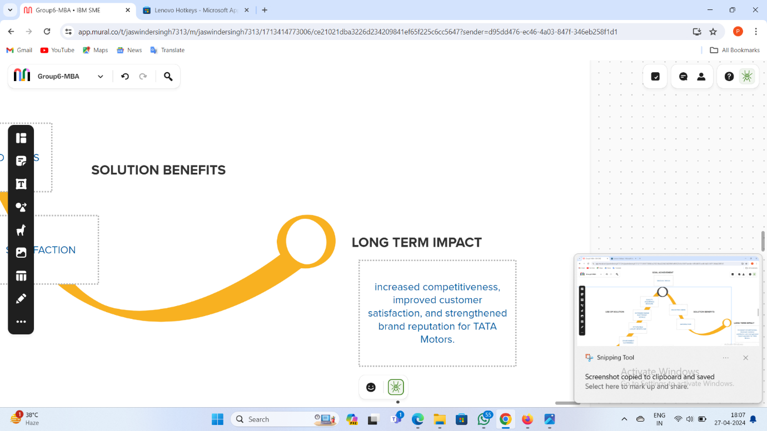

**STORYBOARD**

Crafting a storyboard for a narrative or visual project using MURAL, which may entail sketching scenes, framing shots, and organizing visual elements to steer the storytelling process. **Experimenting with interactive storytelling methods** within MURAL, like branching narratives or choose-your-own-adventure scenarios.

Top of Form

Bottom of Form

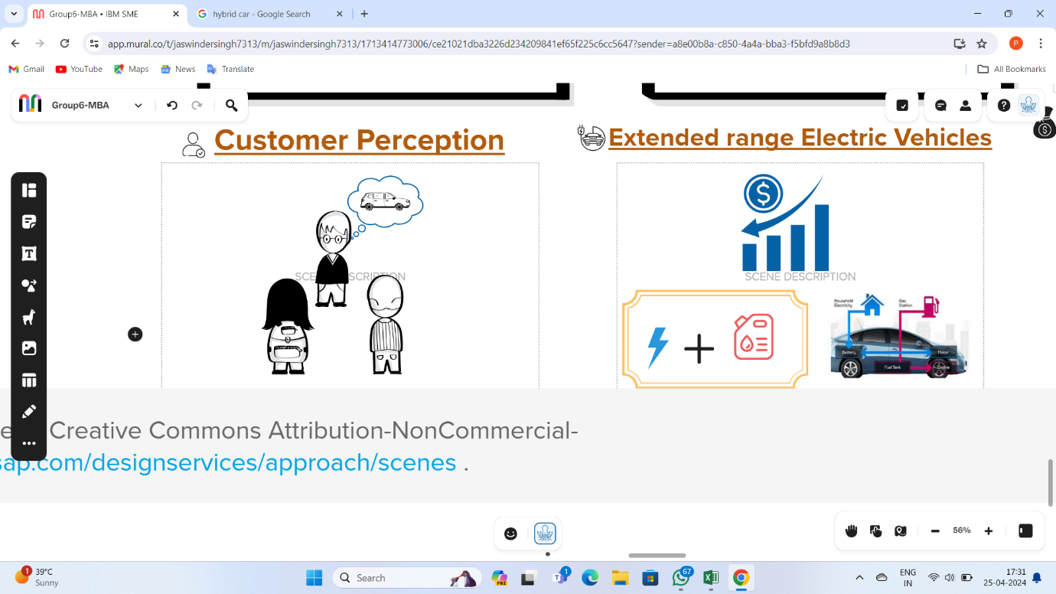

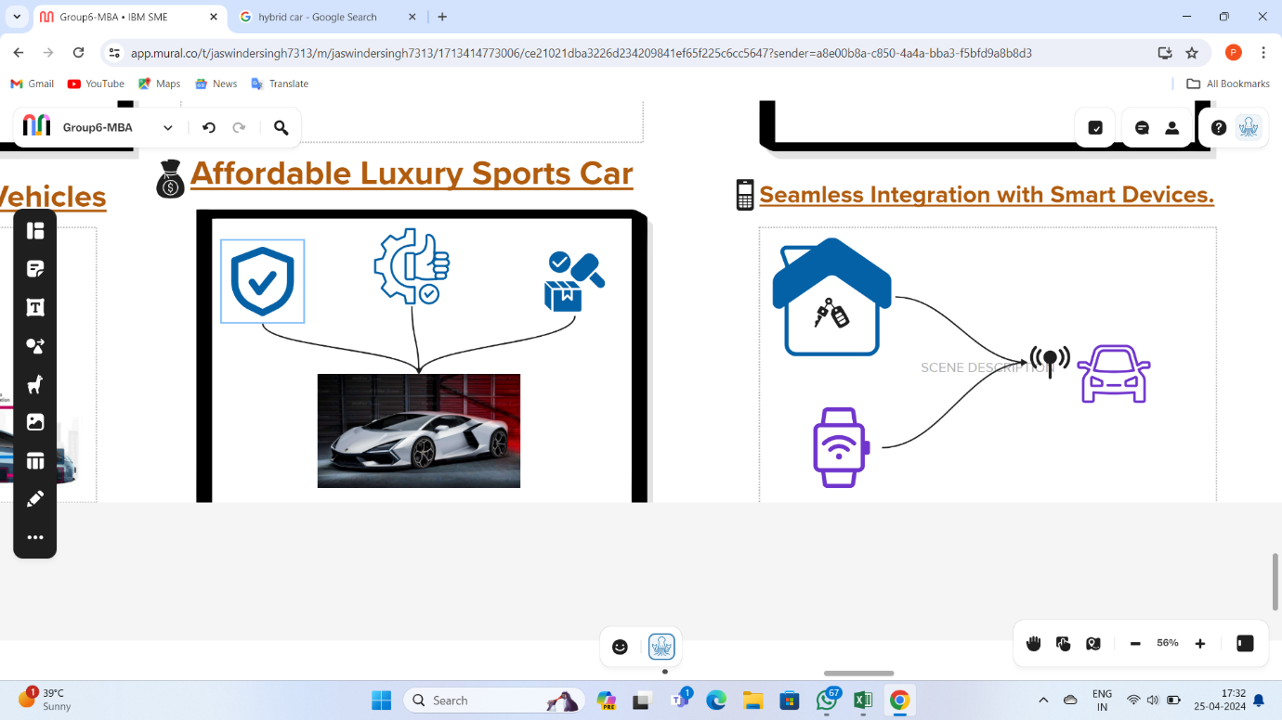

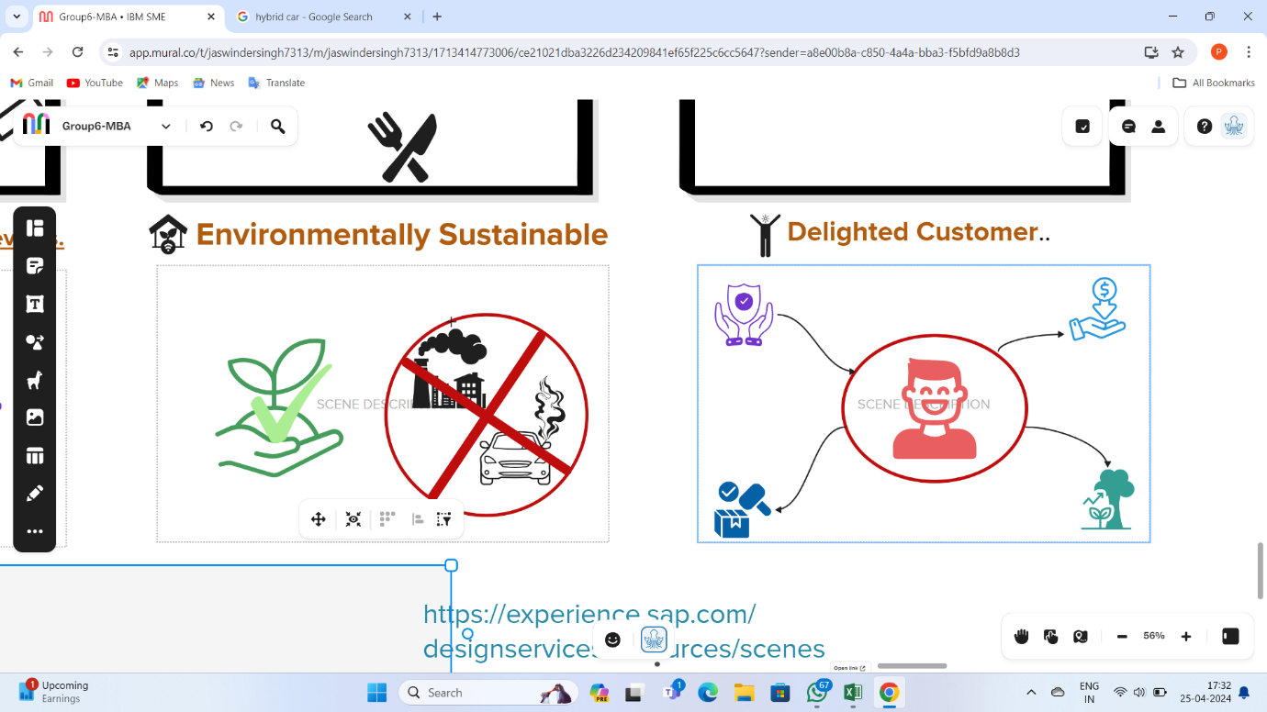

**PRIORITY GRID**

A prioritization matrix is a helpful tool for ranking projects, tasks, or goals. **It helps in evaluating and comparing** various factors like risks, benefits, costs, and stakeholder concerns.

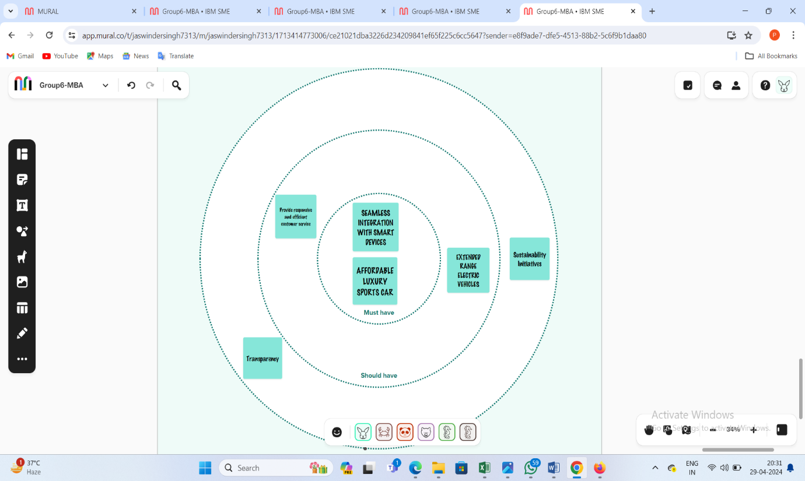

**CRAFTING HILLS**

**"Crafting Hills" is a strategic planning approach**, it aims to assist organizations in establishing ambitious objectives and then dividing them into achievable tasks. When applied in the context of the MURAL tool, "Crafting Hills" likely involves utilizing MURAL's digital canvas and collaboration features for implementing this strategic planning methodology.

